The scenario of sharing storages in Devnet

Tools :

- Docker
- Sector 2 Kb
- Share storage with Docker volume

Configuration :

- Miner
- Worker 77a69335 (C2, PC2 tasks)
- Worker 81346a03 (PC1 task)

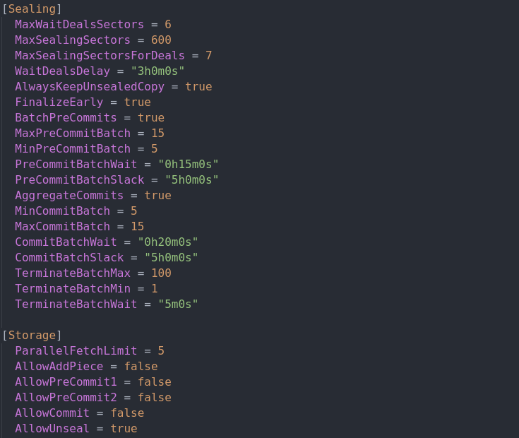

Commands :

- Initialize miner without local storage :

lotus-miner init --no-local-storage --genesis-miner --actor=t01000 --sector-size=2KiB --pre-sealed-sectors=/root/.genesis-sectors --pre-sealed-metadata=/root/.genesis-sectors/pre-seal-t01000.json –nosync

- Initialize workers without local storage :

lotus-worker run --no-local-storage --precommit1=false --precommit2=true --commit=true --listen "0.0.0.0:3457"

- Attach and Init mounted storage for miner :

lotus-miner storage attach --seal --init /root/devnet/storage1
lotus-miner storage attach --seal --init /root/devnet/storage2

- Attach mounted storage for workers :

lotus-worker storage attach --seal /root/devnet/storage1
lotus-worker storage attach --seal /root/devnet/storage2

Workers Info :

Session: 77a69335-5a26-4059-8b75-2131318ba7e3
Enabled: true
Hostname: ip-172-31-36-231
CPUs: 8; GPUs: []
RAM: 15.46 GiB; Swap: 0 B
Reserved memory: 2.223 GiB
Task types: FIN GET UNS C1 C2 PC2 AP

bb56783f-faec-427a-9848-1bfb4059f0a4:
Weight: 10; Use: Seal
Local: /root/devnet/storage1
fac05ecc-8b6b-424f-a33c-e3eb6eb694a8:
Weight: 10; Use: Seal
Local: /root/devnet/storage2

Session: 81346a03-8370-4f98-a259-c5781e0f0901
Enabled: true
Hostname: ip-172-31-36-231
CPUs: 8; GPUs: []
RAM: 15.46 GiB; Swap: 0 B
Reserved memory: 2.548 GiB
Task types: FIN GET UNS C1 PC1 AP

bb56783f-faec-427a-9848-1bfb4059f0a4:
Weight: 10; Use: Seal
Local: /root/devnet/storage1
fac05ecc-8b6b-424f-a33c-e3eb6eb694a8:
Weight: 10; Use: Seal
Local: /root/devnet/storage2
Worker 77a69335 Result :

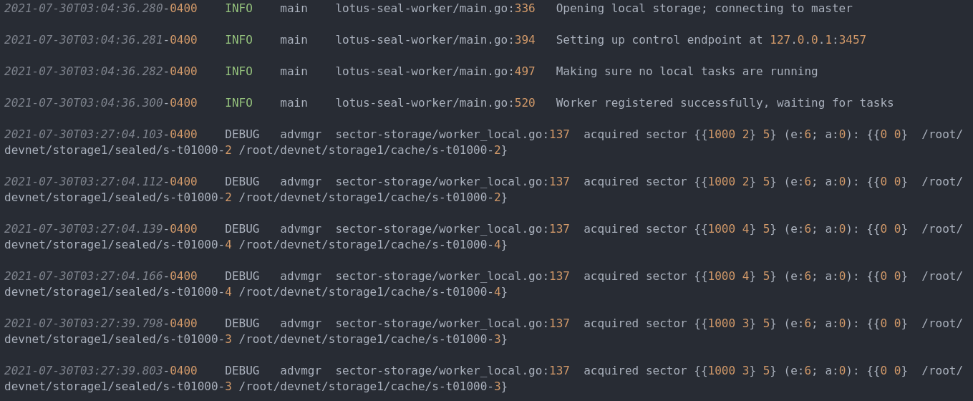
Worker 81346a03 Result :

